LetsUpgrade JavaScript

Day 4 Assignment

**Question 1**

**HTML - index.html**

<!DOCTYPE html>

<html>

<head>

<meta charset="UTF-8">

<title>LetsUpgrade Assignment</title>

</head>

<body>

<img src="https://i.pinimg.com/originals/05/96/1d/05961d2bc589bd5cd2ddddf94ce3e884.jpg" width = "200px" id = "img"><br><br>

<button onclick = "b1()"> Button1</button>

<button onclick = "b2()"> Button2</button>

<button onclick = "b3()"> Button3</button>

<script type = "text/javascript" src = "day4.js"></script>

</body>

</html>

**Day4.js**

function b1(){

const ele = document.getElementById("img");

const newUrl ="https://i.pinimg.com/originals/05/96/1d/05961d2bc589bd5cd2ddddf94ce3e884.jpg";

ele.src = newUrl;

};

function b2(){

const ele = document.getElementById("img");

const newUrl ="https://media1.popsugar-assets.com/files/thumbor/TEfvK0Bf-42CprCfPZNU5seKtBU/fit-in/2048xorig/filters:format_auto-!!-:strip_icc-!!-/2020/08/06/828/n/1922283/tmp_qKZyoG_045ee4883bd1e16b_tsbd1-4.jpg";

ele.src = newUrl;

};

function b3(){

const ele = document.getElementById("img");

const newUrl ="https://encrypted-tbn0.gstatic.com/images?q=tbn%3AANd9GcRuyNe03BBHkZuYaTY7MXRCUw5KrmXqRjLHPg&usqp=CAU";

ele.src = newUrl;

};

**Output :**

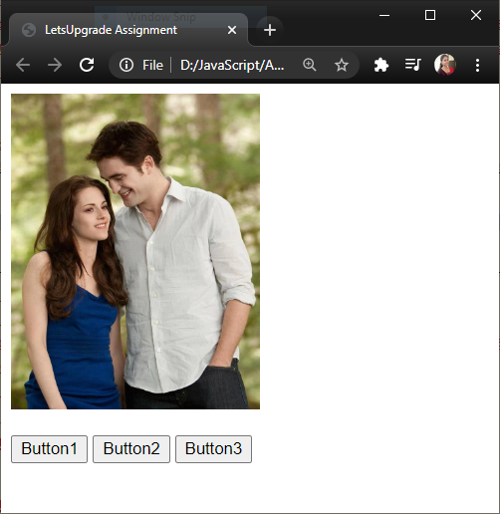

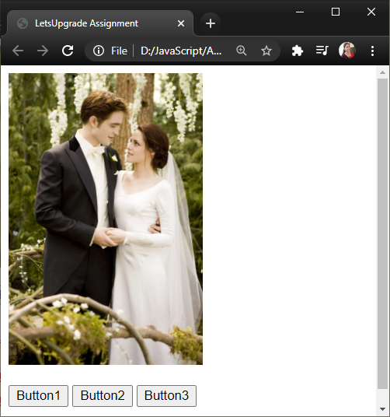

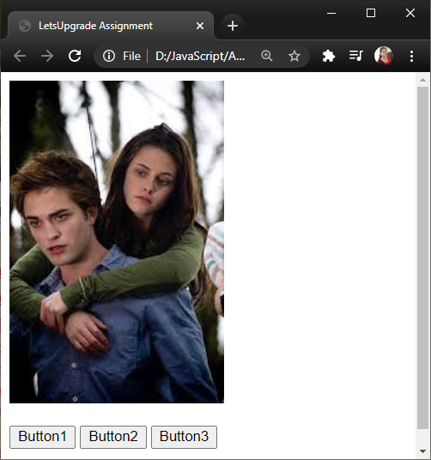

**Question 2**

**Index.html**

<!DOCTYPE html>

<html>

<head>

<meta charset="UTF-8">

<title>LetsUpgrade Assignment</title>

</head>

<body>

Enter Text :<input type = "text" class = "Text1"><br><br>

Click on the button to copy the text to the below textbox<br><br>

<button onclick = "copy()"> Copy</button><br><br>

Copied Text:<input type = "text" class = "Text2"><br>

<script type = "text/javascript" src = "day4.js"></script>

</body>

</html>

**Day4.js**

function copy(){

document.getElementsByClassName("Text2")[0].value = document.getElementsByClassName("Text1")[0].value;

};

**Output :**

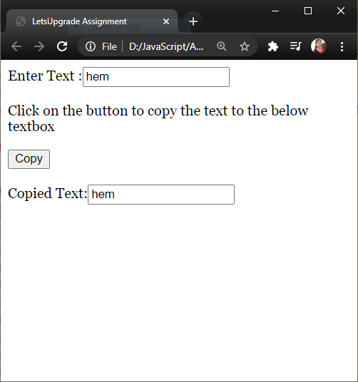

**Question 3**

**HTML - index.html**

<!DOCTYPE html>

<html>

<head>

<meta charset="UTF-8">

<title>LetsUpgrade Assignment</title>

</head>

<body>

Check the console!!!!

<script type = "text/javascript" src = "day4.js"></script>

</body>

</html>

**Day4.js**

let info = [

{

name : "Rohit",

age : 29,

country : "India",

hobbies : ["Cricket","FootBall"],

},

{

name : "Kousi",

age : 21,

country : "India",

hobbies : ["Piano","Cricket"],

},

{

name : "John",

age : 31,

country : "UK",

hobbies : ["Hockey","Swimming"],

},

{

name : "Kristen",

age : 26,

country : "Canada",

hobbies : ["Travelling","BaseBall"],

},

{

name : "Bella",

age : 21,

country : "New York",

hobbies : ["BasketBall","BaseBall"],

},

{

name : "Edward",

age : 46,

country : "Sydney",

hobbies : ["BaseBall","Trecking"],

},]

//B

function displayAll(){

console.log(info);

};

displayAll();

**Output :**

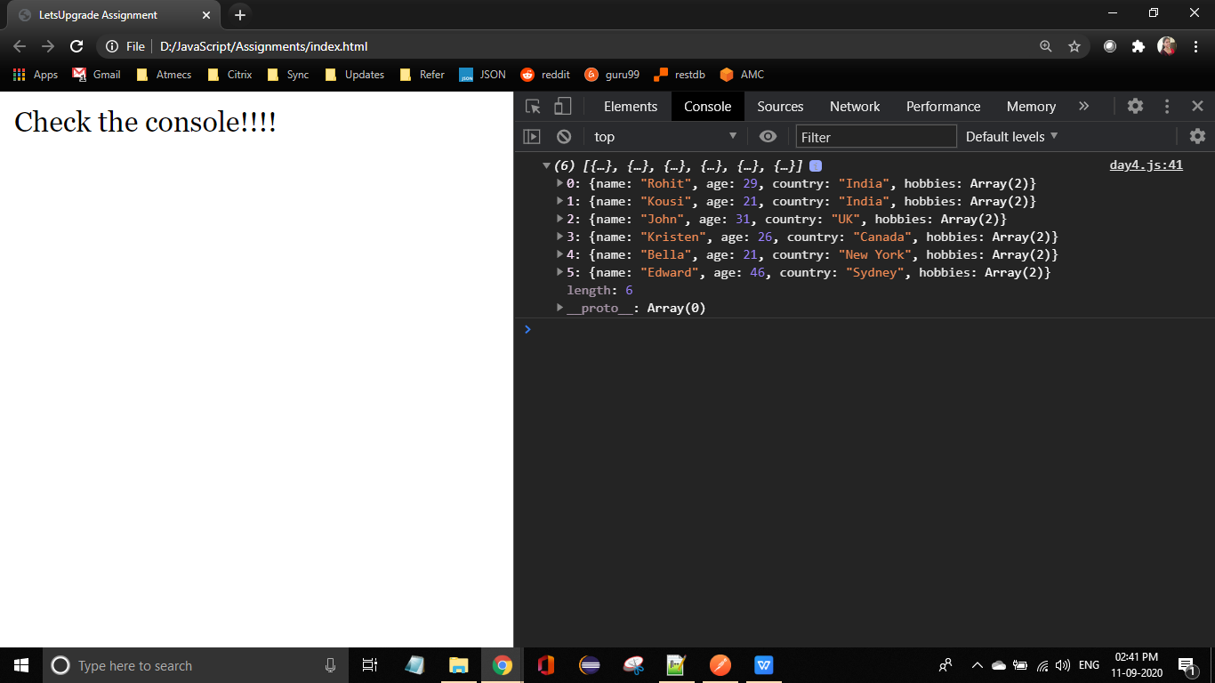

**Question 4 A**

**day4.js** (continuation Q3)

info.forEach(function (below){

if(below.age<30){

console.log(below);

}

});

**Output :**

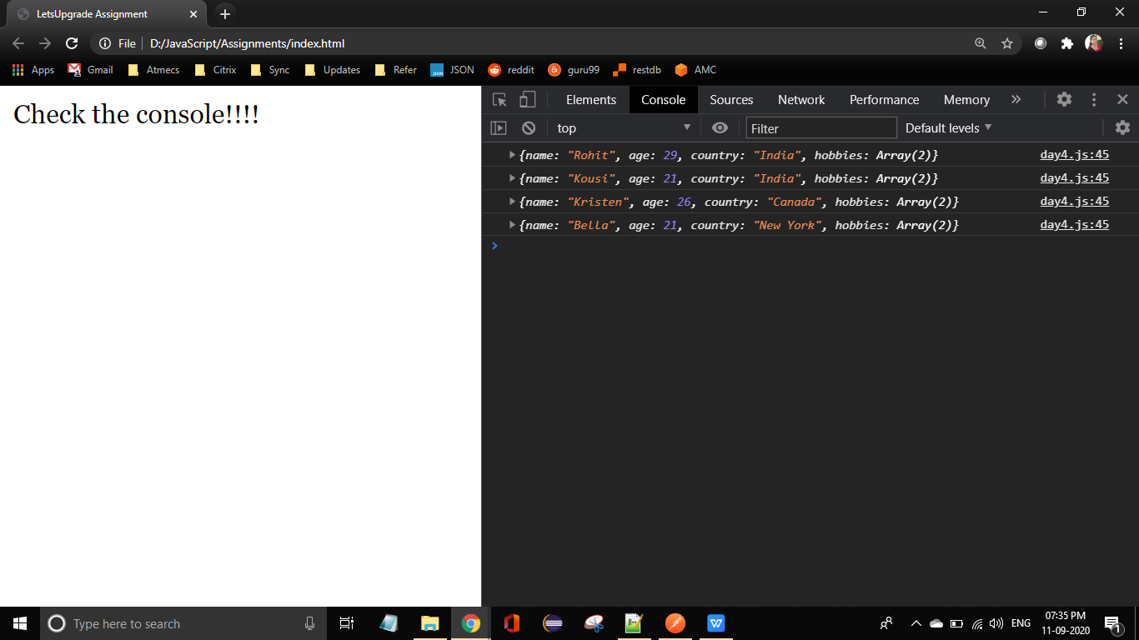

**Question 4 B**

**day4.js** (continuation Q3)

info.forEach(function (below){

if(below.country==="India"){

console.log(below);

}

});

**Output :**

